1. Past Simple vs. Past Continuous
Name: ___________________
Date: ____________________

Fill in the blanks. Use Past Simple or Past Continuous
- I _______________ (watch) TV when my brother _________________ (come) home.
- They _________________ (play) football at 5 p.m. yesterday.
- She ____________________ (break) her leg while she ____________________ (ski).
- I ______________ (walk) in the park when it suddenly ______________ (start) to rain.
- My parents _______________________ (travel) around Italy last summer.
- Tom ________________________________ (not / go) to school yesterday.
- What __________________ you ____________________ (do) at 7 o’clock last night?
- He ____________________ (ride) a bike when he __________________ (fall) down.

2. Выполнить письменно рабочий лист
- Вставить в пропуски слова, данные в рамки
- какие верные/неверные предложения
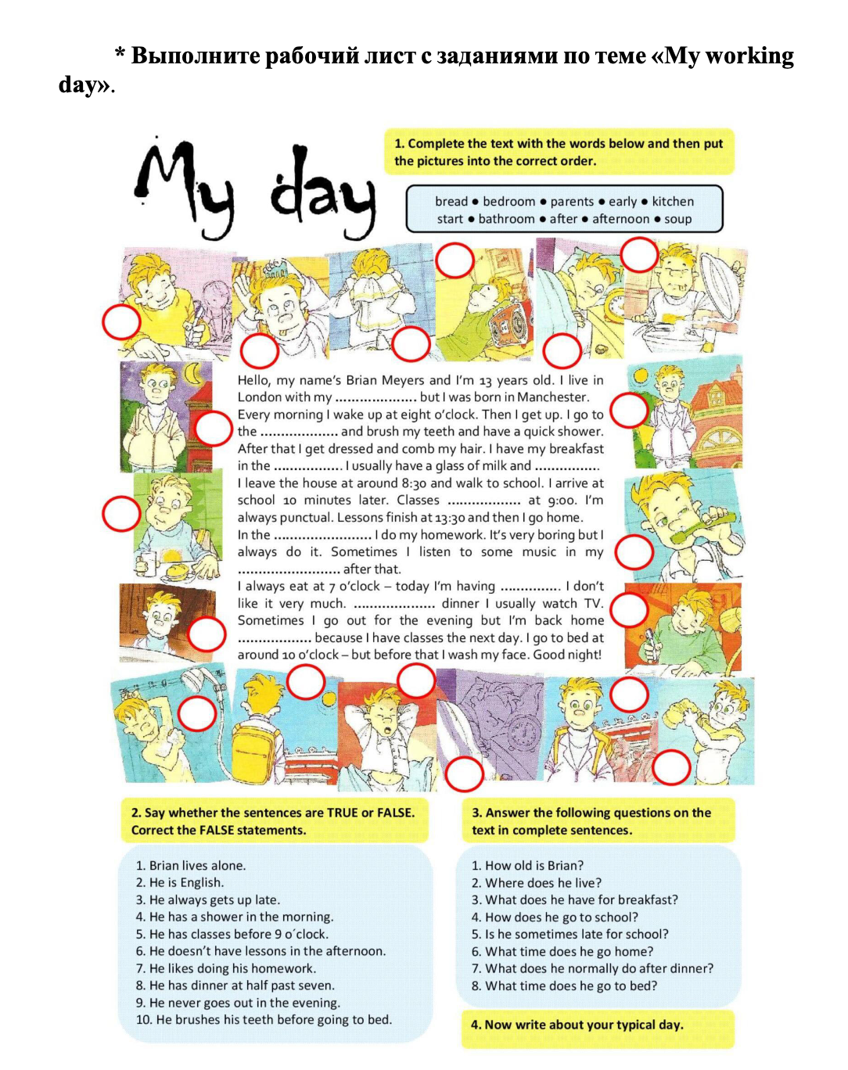
- ответить на вопросы по тексту

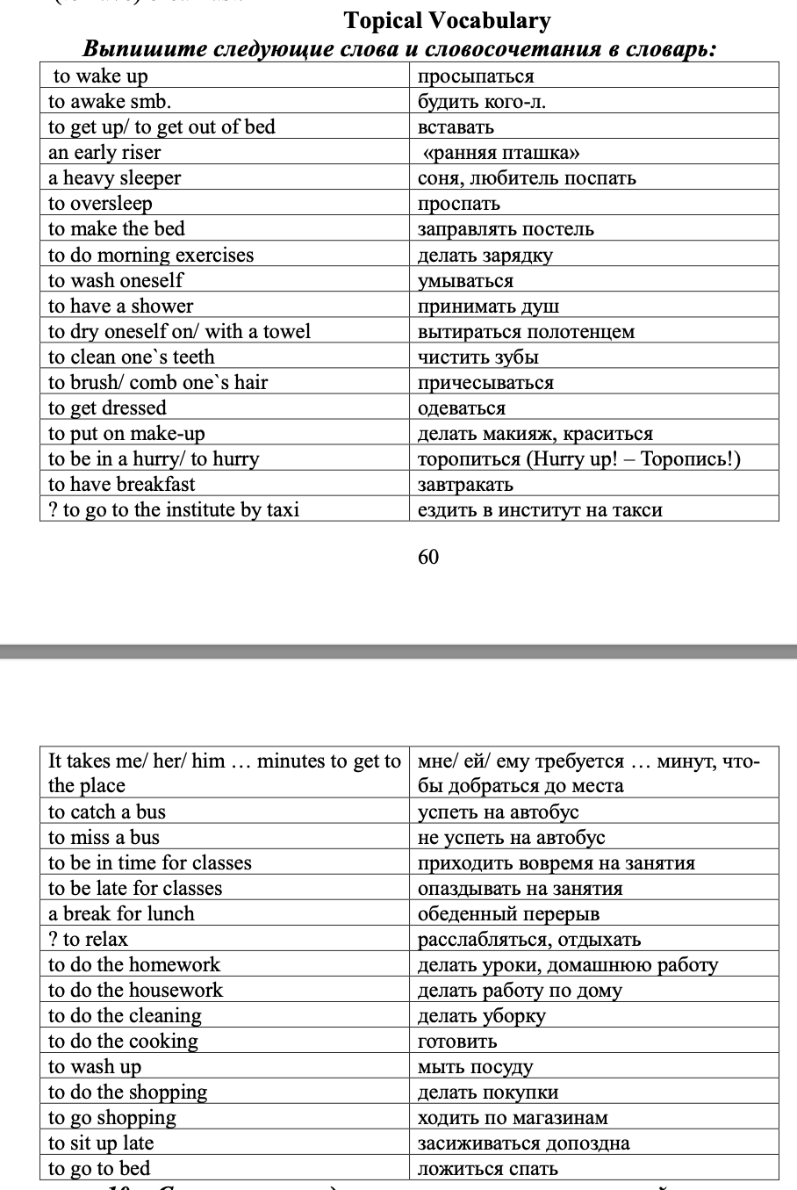
3. Выписать слова в словарь по теме «My working day»

