Future food
1. Complete the text with the words below.
amounts diet dishes flavours leftovers menu portion slice
I’m trying to improve my 1………………………… , but it isn’t easy if you love all types of food like to do. However, I’ve decided that instead of not eating my favourite meals, I’ll just eat smaller 2………………………… of them. That means that I’ll eat a 3………………………… of pizza and not a whole one, and I’ll just have one 4………………………… of takeaway Chinese food instead of two. At least that means there won’t be any 5………………………… filling up the fridge! And when I eat out at a restaurant, I’ll choose the meals on the 6………………………… that include salads and healthy food. The problem is that I like food with strong 7………………………… and tastes, so I’m going to find 8………………………… full of lettuce a bit tasteless!

2. Read the text and answer the questions.
1 What reasons are used to support an insect-based diet?

2 How are supporters of insects as food trying to persuade Americans to eat them?
THE INSECTS ARE COMING!

With an abundance of cheap food and a weakness for junk food, the dietary habits of many Americans (and people in other Western countries) have led to an obesity epidemic. As a result, a growing number of food experts are saying it’s time to replace traditional dishes with more nutritious and also more economical and ecological dishes: dishes that contain insects.

If you put a plate of bugs (as insects are often called in the USA) in front of an American, they, live most Westerners, would probably refuse to eat them. Insects are seen as pests that destroy food crops rather than delicacies to be eaten. 1……… The challenge for the promoters of insect-based meals is to make Americans see them in the same way.

During the 20th century, if you had visited a research department at an American food and agricultural university, you would have heard about how they were trying to reduce insect numbers due to the negative impact they have on crops and seeds. 2……… Furthermore, insect fairs such as the BugFest at the North Carolina Museum or The Great Insect Fair at Penn State University explain that grasshoppers, moths and their cousins are an excellent source of nutrients like protein, minerals and vitamins. The fairs also offer the more adventurous visitors ‘bug banquets’, which serve mouth-watering insect dishes.

Apart from the scientific community, a growing number of market stalls and restaurants are providing insect meals too. 3……… What is more, fans of insect-based cooking like Daniella Martin are spreading the word that bugs are good for you. Martin’s blog Girl Meets Bug, her internet cooking videos and her newspaper columns are all contributing to changing Americans’ perceptions of insects. 4……… While entomophagists (people who eat insects) agree they face an uphill struggle, with 70 million obese citizens and millions more who want to be environmentally friendly, it seems that his could be the right time for insects to invade America’s kitchens.

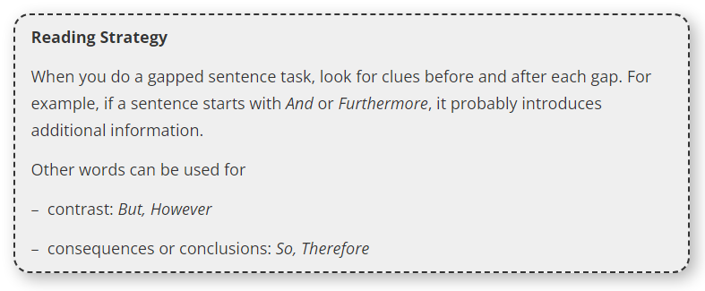
3. Read the Reading Strategy. Then read the text again. Match sentences A-E with gaps 1-4. There is one extra sentence.
A Today, 50% of the same universities promote insects as food.

B The popularity of Mexican food in the USA is also helping, as companies such as Don Bugito offer traditional Mexican insect dishes.

C Moreover, the amount of land needed to produce enough insects to feed the whole country is much smaller than the land needed to produce meat.

D But will it be enough?

E However, in parts of Asia, Africa and Central America, where there are plenty of big, juicy insects all year round, they are considered a delicious staple.
Extra exercises
1. Read the Strategy. Then read the question and the text below. How many statements does the paragraph match? Which statements are they?
The activity the author mentions

1 requires more effort than you think.

2 makes you ache all over.

3 is much easier than people think.

4 helps avoid getting hurt while exercising.

Boxing yoga, as it sounds, is a kind of yoga based on the movements used in boxing. It’s supposed to strengthen, condition and stretch the whole body, as well as prevent sporting injuries. Some gyms have free boxing yoga classes, while others charge per session, but there’s also a video you can pay to download. It’s a pretty strenuous form of exercise, considering it’s yoga, but it makes you feel relaxed and energetic afterwards.
2. Read the text and questions 1-6 below. Match the correct question with each part of the text (A-C). You can match each part with more than one question.
In which paragraph does the author mention an activity which …

1 has become extremely popular recently? …….

2 requires you to do two things at once? …….

3 has made an existing form of exercise more extreme? …….

4 gives the wrong impression to the observer? …….

5 tires you out after a very short time? …….

6 can be particularly painful? …….

The latest fitness trends

A Reformer Pilates is a much more intense form of Pilates. In involves doing the same sort of pushing and stretching exercise, but on equipment resembling a rowing machine. It isn’t the kind of thing you’d have at home, so you have to go to a special Pilates centre to try it. If you do, bear in mind that you won’t be able to walk up or down stairs for a few days afterwards. At first, it looks quite easy, but towards the end of the session, your thighs will be crying out for mercy.

B Jumping up and down on a trampoline is a lot of fun, but it can make a great workout too. You’d be surprised by how exhausted you are after only a few minutes bouncing. Not only is it better for the heart than running, but it also increases co-ordination and helps reduce stress levels. Trampolining is taking off in a big way, and some new centres have as many as 150 trampolines. You can either have a go at ‘freejumping’ – without an instructor – or pay someone to teach you how to do it properly.

C If you’re usually quite active, but you’re feeling down in the dumps, then you might like to try Dynamic Running Therapy – going out for a run with a therapist. The sessions are quite pricey as the therapists are professionals and they charge a bit more than the going rate. It’s easier to do both activities when you’re running and talking at the same time: you run further because you don’t notice your sore feet, and you talk more freely than you would in the therapist’s office.

