Задание 1
ПИСЬМЕННО выполнить задания 1,2,3,4 после текста в тетради или печатном виде и выложить в электронную среду в формате PDF, JPG
Тext 1
My Family
Let me introduce myself. My name is Philip Stanley. I am 40. I am a doctor. I
work at a hospital in Liverpool. Liverpool is the biggest city in Lancashire. I like my work very much. I am married. My wife’s name is Linda. She is 32. She is kind and beautiful. She is a teacher at school. Our hobby is working in the garden. Our daughter Nora is 12. She is a schoolgirl. She looks like her mother and takes after her mother in character. Her hobby is dancing.
My parents are farmers. They have got a farm not far from the city. They breed
pigs. But best of all they like roses. They have to work from morning till night. I have got many relatives: uncles, aunts, cousins, nephews. We often get together at our parents’ house.

Exercise 1. Read the text.

Exercise 2. Agree or disagree with the following statements (yes/no):

1) Philip Stanley is a farmer.
2) He lives in the biggest city of Lancashire.
3) He is married and has got a son.
4) Linda is a doctor.
5) Linda’s hobby is dancing.
6) Their parents’ farm is far from the city.
7) They breed pigs and rabbits.
8) They are a close family.

Exercise 3. Complete the chart with information about Philip’s family.
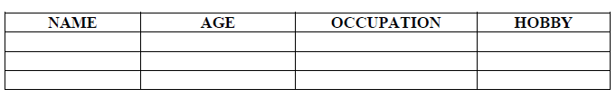

Exercise 4. Write about your family (no less than 15 sentences).

